# 4.1: Waste Characterization in the Study Area

The composition of total household waste collected from the study area, which comprises Eti-Osa, Ikeja and Alimosho Local Government Area is presented in Table 4.1. A total of 149.7kg of solid waste was collected from the study area. The waste realized from the waste sample collected from the study area includes organic waste, metal waste, plastic waste, paper waste and glass waste, 50.6, 45.6, 27.6, 9.7 and 16.2kg respectively.

The trend observed in the study was that the mass of household organic waste (food waste), metal waste and plastic waste were highest in Eti-Osa LGA (19.3, 20.2 and 16.8 kg) and lowest in Alimosho LGA (13.1, 10.2 and 9.2 kg) respectively. 33.80% of the solid waste generated in the study area were made up of organic waste (food waste such as yam/potato peel, plantain peel, egg shells, and vegetables/fruits waste), followed by metal waste which generated 30.46 % (empty can drink, caps of bottles, bent spoons and cups, electrical parts), plastic waste generated 18.44% (pet bottles, empty sachet water, plastic bottles, fast food packets), paper/cartons were 6.48% while glass forms of waste generated were 10.82%. The waste realized comprises of 33.8% organic waste, 30.46% metal waste, 18.44% plastic waste, 6.48% paper waste and 10.82% glass waste. Furthermore, organic waste/food waste had the highest percentage of 33.8% across the study area followed by metal waste, with 30.46%, plastic waste with 18.44%, glass waste with 10.82.7% and paper waste with 6.48%. Overall, the total waste collected was highest at Eti-Osa (64.5kg) followed by Ikeja (48.7kg) and Alimosho (36.5kg) respectively.

In Alimosho, organic waste had the highest percentage (35.89%) of the total waste collected for the area, followed by metal waste (27.95%), plastic waste (18.36%), glass waste (10.96%) and paper waste (6.85%). In Ikeja, organic waste had the highest percentage (37.37%) of the total waste collected for the area, followed by metal waste (31.21%), plastic waste (16.02%), glass waste (8.21%) and paper waste (7.19%). In Eti-Osa, the trend observed was that metal waste had the highest percentage (31.21%) of the total waste collected for the area, followed by organic waste (29.92%), plastic waste (20.31%), glass waste (12.71%) and paper waste (5.74%).

The mass of the physical components of household waste in the study such as organic waste which recorded the highest mass of 34 % followed by metal waste at 30 %, plastic waste at 18 kg, glass forms of waste at 11 kg and paper/cartons with 7 % respectively

# Table 4.1: Characterization of Household Solid Waste from three local government areas in Lagos state, Nigeria.

|  |  |  |  |  |  |  |  |
| --- | --- | --- | --- | --- | --- | --- | --- |
| **Components** | **Types** | **Weight (Kg) of Waste collected** | | | | **Percentage (%)** | |
| **Alimosho LGA** | **Ikeja LGA** | **Eti-Osa LGA** | **Overall** | |  | |
| Organic waste | Yam/Potato Peel | 3.8 | 6.2 | 5.1 | 15.1 | | 10.09 | |
|  | Plantain Peel | 3 | 3 | 3.2 | 9.2 | | 6.15 | |
|  | Egg Shell | 0.8 | 1.2 | 2.5 | 4.5 | | 3.01 | |
|  | Vegetables and Fruits | 5.5 | 7.8 | 8.5 | 21.8 | | 14.56 | |
| Metal waste | Empty Can Drinks | 3.2 | 4.7 | 6 | 13.9 | | 9.29 | |
|  | Caps of Bottles | 2.6 | 3 | 4 | 9.6 | | 6.41 | |
|  | Bent Spoons and Cups | 2 | 3 | 3 | 8 | | 5.34 | |
|  | Electrical/Mech. Parts | 2.4 | 4.5 | 7.2 | 14.1 | | 9.42 | |
| Plastic waste | Pet bottles | 2 | 2.5 | 3.6 | 8.1 | | 5.41 | |
|  | Empty Sachet Water | 2.5 | 1.1 | 1 | 4.6 | | 3.07 | |
|  | Plastic Bottles | 1.2 | 1.2 | 3.5 | 5.9 | | 3.94 | |
|  | Fast Food Packets | 1 | 3 | 5 | 9 | | 6.01 | |
| Papers and glass | Paper/cartons | 2.5 | 3.5 | 3.7 | 9.7 | | 6.48 | |
|  | Glass | 4 | 4 | 8.2 | 16.2 | | 10.82 | |
|  | **Total** | **36.5** | **48.7** | **64.5** | **149.7** | | **100** | |

**4.2. Comparison of waste collected across the local government areas**

**4.2.1. Yam and potatoe peel wastes**

The weight of yam and potato peel waste collected from domestic households in Ikeja, Eti-Osa, and Alimosho showed significant variation (F=56.6; p <0.05) (Figure 1). The average weight of waste was highest in Ikeja (118.42 ± 17.25 g), followed by Eti-Osa (107.20±25.63 g), and lowest in Alimosho (68.27 ± 29.69 g). Statistical analysis revealed no significant difference (P > 0.05) between the waste weights in Ikeja and Eti-Osa, while a significant difference (P < 0.05) was found between Alimosho and the other two areas. This indicates that while Ikeja and Eti-Osa have similar yam and potato peel waste levels, Alimosho produces significantly less.

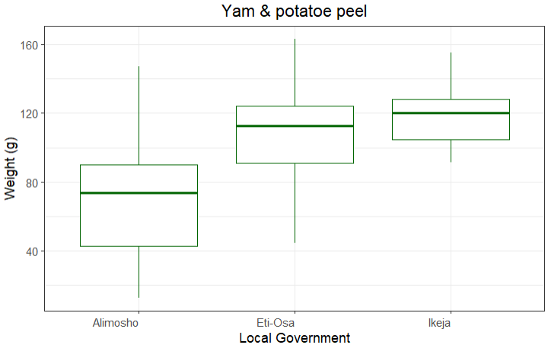

Figure 1: Weight distribution of Yam and potatoe peel in all local government areas (n=50).

**4.2.2. Plantain peel waste distribution**

The analysis of plantain peel waste from domestic households in Eti-Osa, Alimosho, and Ikeja showed no significant differences (F=0.292, p>0.05) in the weight of waste across the three areas (Figure 2). The average weight of plantain peel waste was similar in all three local government areas, with Eti-Osa having a mean of 62.81 + 24.49 g, Alimosho at 60.87 + 17.66 g, and Ikeja at 59.96 + 13.32g. Statistical analysis revealed no significant differences (P > 0.05) between the areas, indicating that plantain peel waste generation is comparable across the three local government areas.

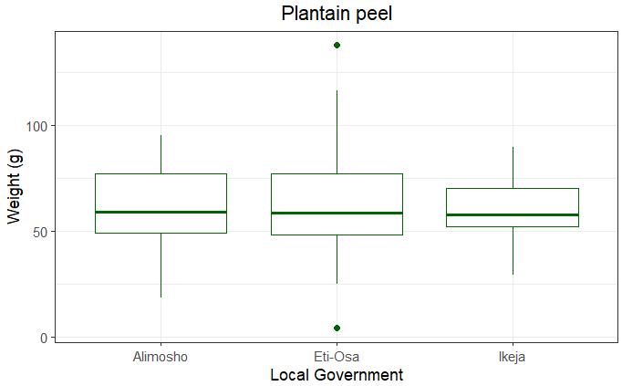

Figure 2: Weight distribution of plantain peel in all local government areas (n=50).

**4.2.3. Eggshell waste distribution**

Eggshell waste from domestic households in Eti-Osa, Ikeja, and Alimosho revealed significant differences (F =140.6, p< 0.001) in the weight of waste across the three local government areas. The mean weight of eggshell waste was highest in Eti-Osa (48.46+13.95 g), followed by Ikeja (22.5+8.66g), and lowest in Alimosho (14.67+7.99g). Statistical analysis showed significant differences (P < 0.05) between all three areas, with Eti-Osa generating the most eggshell waste, followed by Ikeja, and Alimosho producing the least.

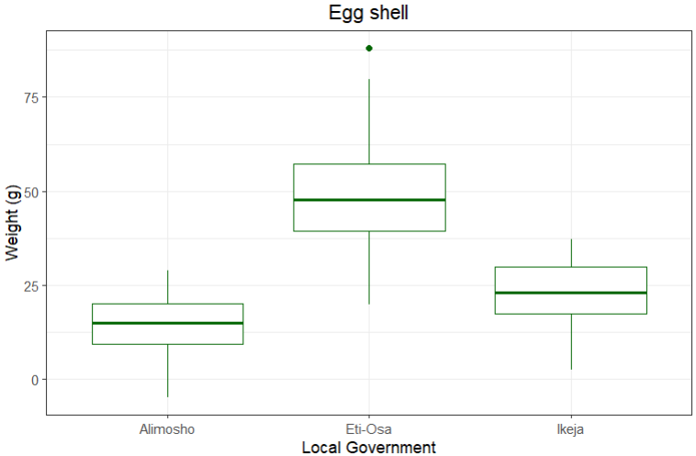

Figure 3: Weight of Egg shells collected from all three local governments

**4.2.4. Vegetables and fruit waste distribution**

The analysis of vegetable and fruit waste from domestic households in Eti-Osa, Ikeja, and Alimosho revealed significant differences in the weight of waste across the three local government areas. The mean weight of vegetable and fruit waste was highest in Eti-Osa (172.54+14.79 g), followed by Ikeja (160.78+21.48g), and lowest in Alimosho (110.91+23.61g). Statistical analysis indicated significant differences (P < 0.05) between all three areas, with Eti-Osa generating the highest amount of waste, followed by Ikeja, and Alimosho producing the least.

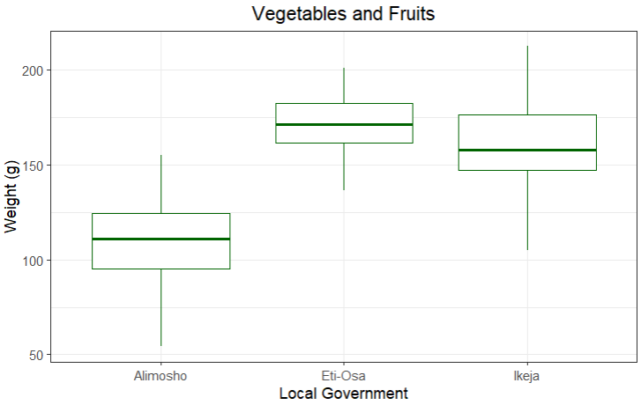

**Figure 3**: Weight of Fruits and Vegetables collected from all three local governments

**4.2.5. Empty drink cans waste distribution**

Empty drink can waste from domestic households in Eti-Osa, Ikeja, and Alimosho showed significant differences (F=106.7; p<0.001) in the weight of waste across the three local government areas. The mean weight of empty drink can waste was highest in Eti-Osa (123.37+19.2g), followed by Ikeja (98.25+25.3g), and lowest in Alimosho (63.42+16.28g). Statistical analysis revealed significant differences (P < 0.05) between all three areas, with Eti-Osa generating the most waste, Ikeja producing a moderate amount, and Alimosho the least.

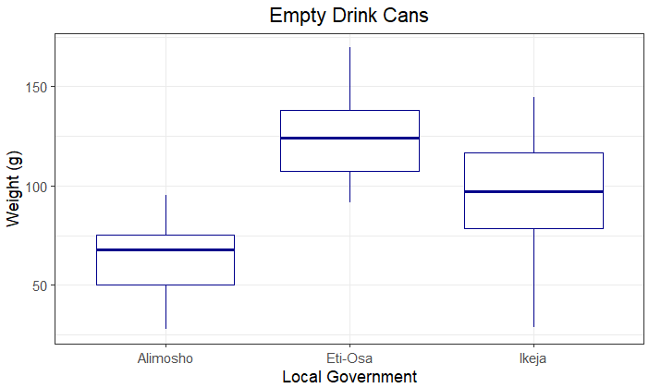

**Figure 3**: Weight of Empty drink cans collected from all three local governments

**4.2.6. Bottle caps waste distribution**

Bottle cap waste generation varied significantly across the three local government areas. Eti-Osa recorded the highest mean weight of 80.8+17.9g, with Ikeja following at 58.79+12.36g, and Alimosho generating the least at 50.12+8.39g. Statistical analysis confirmed that these differences were significant (P < 0.05), with each area distinctly differing in waste output. These results indicate that households in Eti-Osa contribute the most to bottle cap waste, while those in Alimosho contribute the least, underscoring clear differences in waste generation across the LGAs.

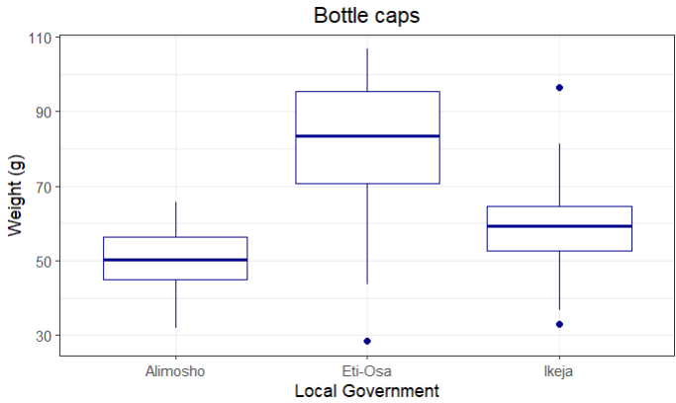

Figure 6: Weights of bottle caps waste collected from all three local governments

**4.2.7. Bent Spoons and Cups Waste distribution**

Bent spoon and cup waste from domestic households in Ikeja, Eti-Osa, and Alimosho revealed notable differences (F=6.717, p < 0.01) in waste weight. Ikeja recorded the highest mean weight (61.59+20.42 g), followed by Eti-Osa (53.93+47.52 g), and Alimosho had the lowest (39.94+3.99 g). Statistical analysis showed that the difference between Ikeja and Alimosho was significant (P < 0.05). However, there was no significant difference (P > 0.05) between Eti-Osa and either Ikeja or Alimosho. These results show that waste generation for bent spoons and cups is highest in Ikeja, while Alimosho produces the least, with Eti-Osa falling in between.

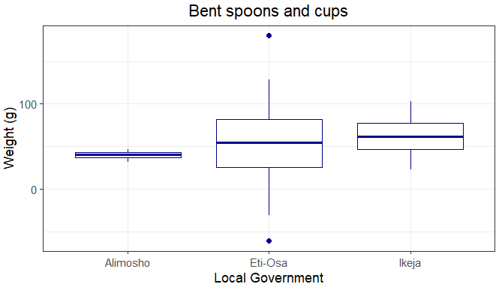

Figure 7: Weights of bent spoon and cups collected from the three local government areas.

**4.2.8. Electrical and Mechanical Parts Waste Distribution**

The distribution of electrical and mechanical parts waste from domestic households varied significantly (F= 221.8, p<0.001) across Eti-Osa, Ikeja, and Alimosho. Eti-Osa generated the highest mean weight of waste at 145.05+34.98g, followed by Ikeja with 92.77+13.91g, while Alimosho produced the least at 48.38+12.88 g. Statistical analysis confirmed significant differences (P < 0.05) between all three areas. These indicate that households in Eti-Osa contribute substantially more to electrical and mechanical parts waste compared to Ikeja and Alimosho, with the latter producing the lowest amounts.

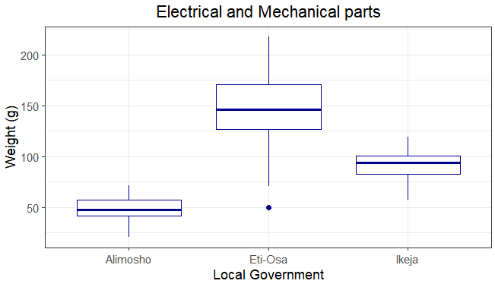

Figure 8: Weight of electrical and mechanical parts collected from the three local government areas.

**4.2.9. Pet bottle waste distribution**

The distribution of pet bottle waste from domestic households showed significant differences across the three local government areas. Eti-Osa recorded the highest mean weight of waste at 70.85+8.81g, followed by Ikeja with 50.37+15.53 g, and Alimosho with the lowest at 40.28+17.6g. Statistical post-hoc analysis confirmed that these differences were significant (P < 0.05) between all three Local government areas. These results highlight that households in Eti-Osa generate the most pet bottle waste, while Alimosho contributes the least, indicating a clear variation in waste generation patterns across the LGAs.

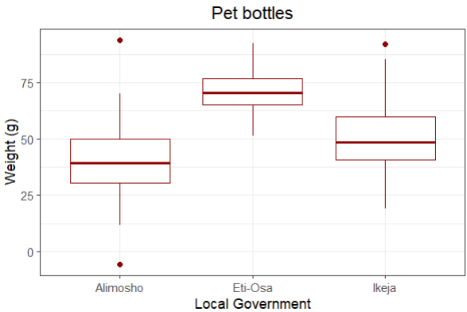

**Figure 9:** Weight of pet bottle wastes collected from three local governments in Lagos state.

**4.2.10. Empty water sachets waste distribution**

The distribution of empty water sachet waste from domestic households varied significantly (F= 121.2, p< 0.001) across Alimosho, Ikeja, and Eti-Osa (Figure 10). Alimosho generated the highest mean weight of waste at 49.73+10.49g, followed by Ikeja with 25.57+13.23g, while Eti-Osa produced the least at 19.36+5.78 g. Post-hoc analysis revealed significant differences (P < 0.05) between all three local government areas.

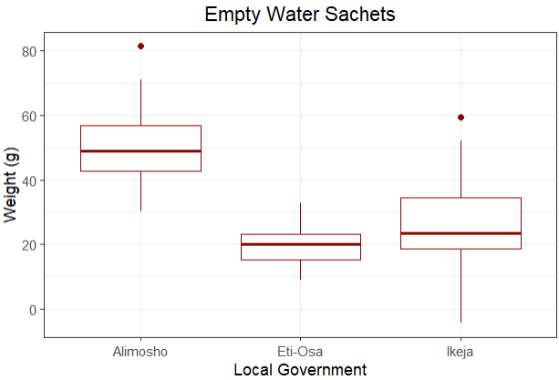

**Figure 10**: Weight of empty water sachets collected from three local government areas in Lagos state.

**4.2.11. Plastic bottle waste distribution**

The analysis of plastic waste collected from domestic households revealed significant differences (F=78.49, p<0.001) in waste generation across Eti-Osa, Ikeja, and Alimosho. Eti-Osa recorded the highest mean weight at 66.43+21.61g, significantly greater (P < 0.05) than both Ikeja (24.6+20.13g) and Alimosho (24.6+20.13g), which did not differ significantly (P > 0.05) from each other. These results highlight that Eti-Osa generates substantially more plastic waste compared to the other two areas, which have similar levels of plastic waste generation.

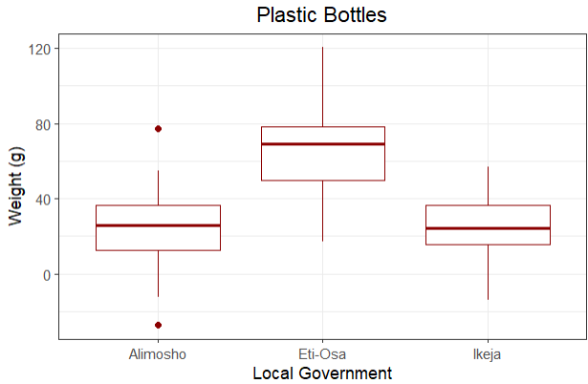

Figure 11: Weights of plastic bottles collected from three local government areas in Lagos state

**4.2.12. Fast-food waste distribution**

The analysis of fast-food packet waste from domestic households revealed significant differences in waste generation across Eti-Osa, Ikeja, and Alimosho (F= 630.0, p<0.001). Eti-Osa produced the highest mean weight of waste at 102.74+12.27 g, followed by Ikeja at 61.07+14.83g, and Alimosho at 20.23+5.88 g. Post-hoc analysis confirmed significant differences (P < 0.05) between all three areas. These indicate that households in Eti-Osa contribute the most to fast-food packet waste, with Ikeja producing a moderate amount and Alimosho the least.

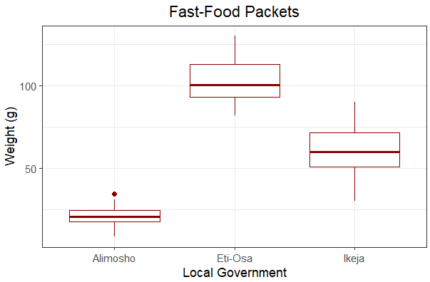

**Figure 12:** Weights of fast-food packets collected from three local government areas in Lagos state.

**4.2.13. Paper and Carton waste distribution**

Waste generation from paper and cartons varied across the three local government areas (F=28.19, p<0.001). Eti-Osa and Ikeja had similar levels of waste, with mean weights of 71.78+9.90g and 70.71+21.3 g, respectively. In contrast, Alimosho had a significantly lower mean weight of 48.65 +18.85g. Post-hoc statistical analysis revealed that the difference between Alimosho and the other two areas was significant (P < 0.05), while there was no significant difference between Eti-Osa and Ikeja. These highlight a distinct pattern of higher paper and carton waste generation in Eti-Osa and Ikeja, with Alimosho producing notably less.

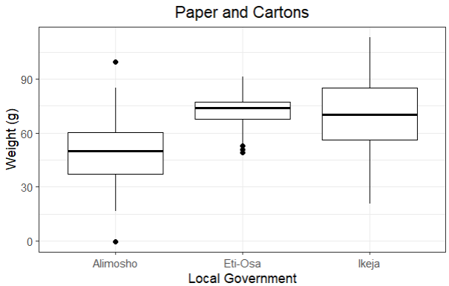

**Figure 13:** Weights of paper and cartons collected from domestic houses in three local governments in Lagos state.

**4.2.14. Glass waste distribution**

The distribution of glass waste from domestic households showed significant differences (F=344.8, p<0.001) across the three local government areas. Eti-Osa generated the highest mean weight of glass waste at 162.70+14.78 g, significantly higher (P < 0.05) than both Alimosho (81.25 +23.01g) and Ikeja (77.81+16.01 g), which did not differ significantly from each other. These indicate that glass waste generation is substantially higher in Eti-Osa compared to the other areas, with Alimosho and Ikeja producing similar amounts of waste.

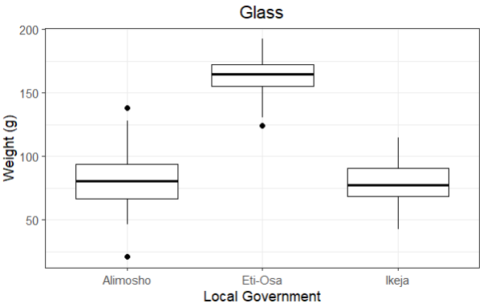

**Figure 14:** Weights of glass wastes collected from domestic houses in three local government areas in Lagos state.

**4.3. Relationships between the waste distribution across all households**

**4.3.1. Relationships between the waste distribution across all households in all local government area**

The relationship between the 14 waste types is presented in Pearson’s correlation matrix (Figure 15). Here, there was a negative relationship (r=-0.51) between ‘yam and potato peel’ and Empty water sachets. Similarly, weak relationship was seen between empty water sachets and egg shell (r=-0.51), vegetables and fruits (r=-0.63), empty drink cans (r=-0.62), bottle caps (r=-0.42), electrical and mechanical parts (r=-0.64), pet bottles (r=-0.47), plastic bottles (r=-0.39), fast-food packets (r=-0.69), paper and cartons (r=-0.42) and glass (r=-0.47).

Strong positive relationships (r>0.7) were observed between egg-shells and bottle fast-food packets and glasses. Also, Fast-food packets show strong relationships (r>0.7) with ‘electrical and mechanical parts’, bottle caps and empty drink cans.

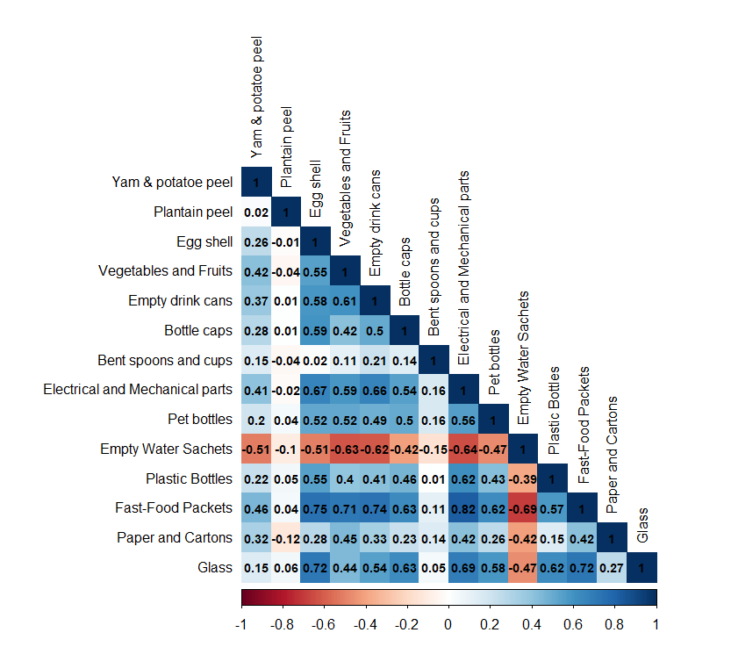

**Figure 15:** Correlation matrix of overall waste types from 150 domestic houses across all local government areas inspected.

**4.3.2. Relationships between the waste distribution across all households in Alimosho local government area**

For the Alimosho local government area, the waste distribution shows (mostly) weak and moderately positive and negative relationships with each other (Figure 16). Notably, Yam and potatoe peel had a negative relationship (r=-0.31) with egg shells, bent spoons and cups. Bottle caps had a positive relationship with egg shell wastes. Other relationships were considered null or significantly weak.

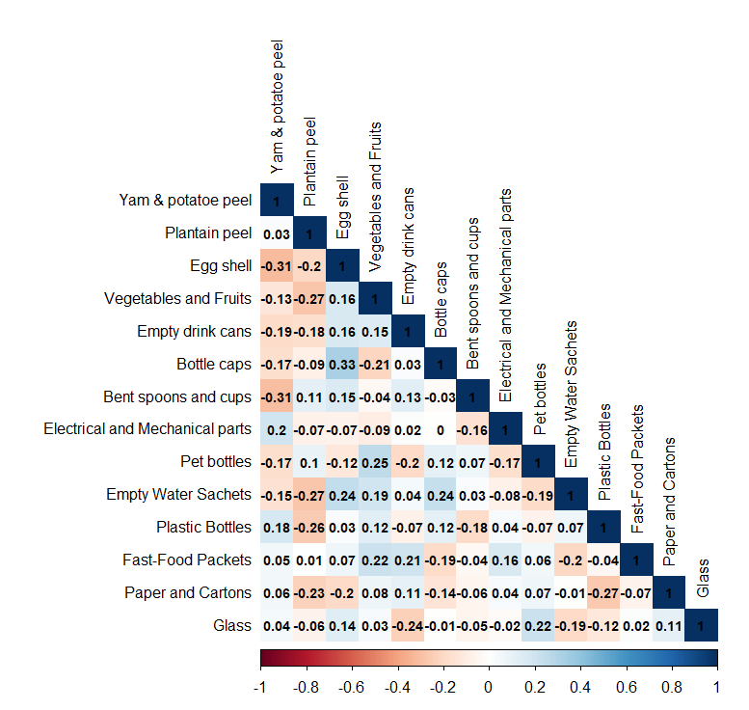

**Figure 16:** Correlation matrix of overall waste types from domestic houses in Alimosho local government area, Lagos state.

**4.2.3 Relationships between the waste distribution across all households in Ikeja local government area**

The relationship between all 14 waste types collected from the Ikeja local government area showed no strong or moderate relationship. However, some notable relationships include the weak negative relationship (r=-0.21) between paper and cartons and yam and potatoe peel. Plantain peel had a weak negative relationship (r=-0.52) with vegetables and fruits. Egg shell had a weak negative relationship (r=-0.22) with bent spoons and cups. Plastic bottles had a weak relationship with fast-food packers and fast-food packets which also had a weak relationship with paper and cartons. Moreover, a weak positive relationship (r=0.28) was seen between bent spoons and empty water sachets., and bottle caps had a positive relationship with pet bottles (r=0.22).

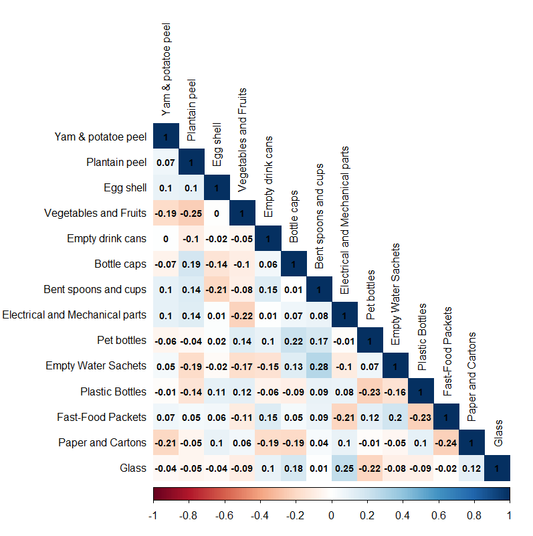

**Figure 17:** Correlation matrix of overall waste types from domestic houses in Ikeja local government area, Lagos state.

**4.3.4. Relationships between the waste distribution across all households in Eti-Osa local government area**

The Pearson correlation matrix of all waste types collected from Eti-Osa local government is presented in Figure 18. Most of their relationships are weak to moderately weak. However notable weak relationship was observed between pet bottles and ‘paper and cartons’, ‘bent spoons and cups’ and fast food packets, ‘vegetables and fruits’ and ‘bent spoons and cups’, and in the correlation between ‘electrical and mechanical parts’ and ‘vegetables and fruits’. On the other hand, a moderate positive relationship is seen between glass and empty water sachets and a weak relationship between fast-food packets and ‘paper and cartons’.

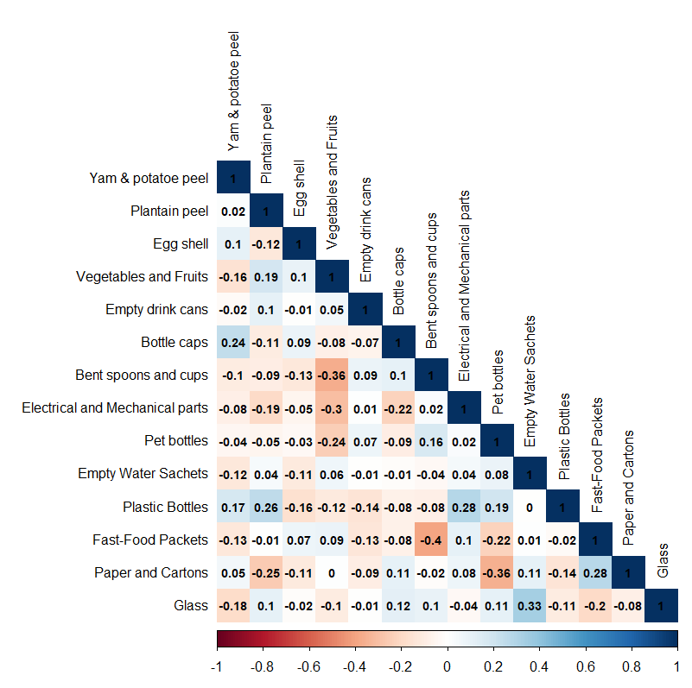

**Figure 18:** Correlation matrix of overall waste types from domestic houses in Eti-Osa local government area, Lagos state.